Team CERC’s Pa consulting Project

Team Name: Team CERC

Chosen theme: Dyslexia, Crowd Management

Team members’ names: Vivek Kommi, Ash Katuri, Sai Batchu, Pranav Mullapudi

Location: Cambridge, UK

**Introduction:**

We have looked at two major problems in our community that we could solve. We will give you a brief insight of the two. One of our projects is a Raspberry Pi Dictionary and Translator. This project was aimed at those whose first language was not English and those who suffer from dyslexia. It does many things such as giving the definition, word class and can translate it to other native languages for others.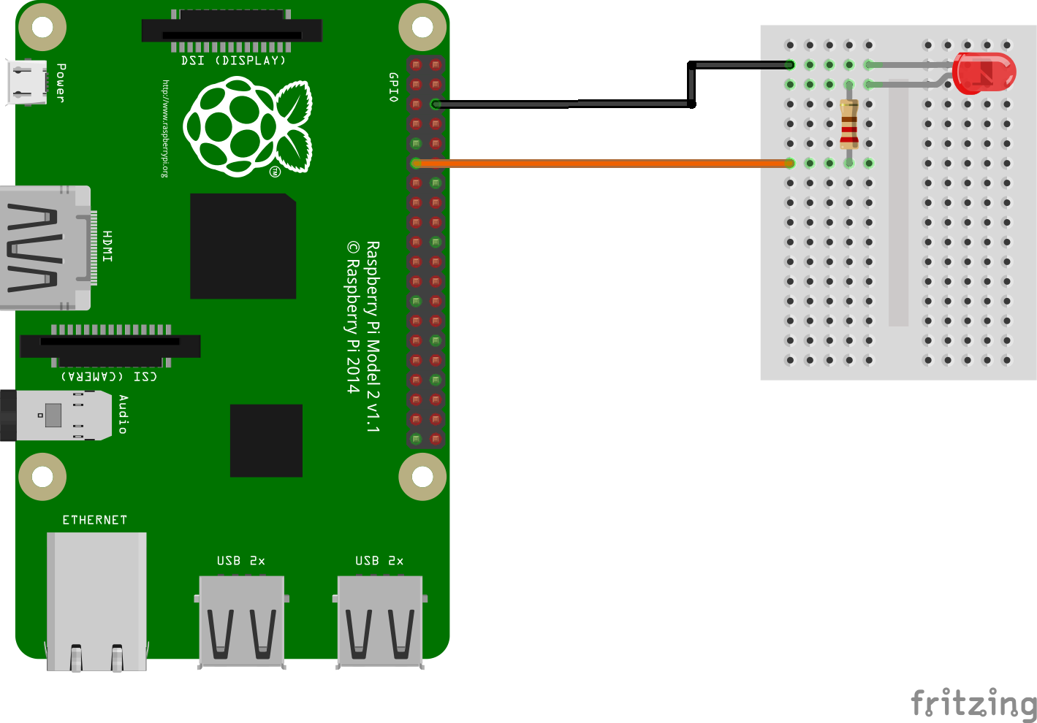

**Method:**

The raspberry pi dictionary uses 3 libraries, OpenCV, tesseract and pydictionary. The tesseract library can convert from an image to text, whereas the open cv library can detect the words and the pydictionary does the translation, definition and word class of the word. We have been able to translate from English to 3 languages so far, Hindi, German and Mandarin. The Google translate app is our main competitor, since it offers real time 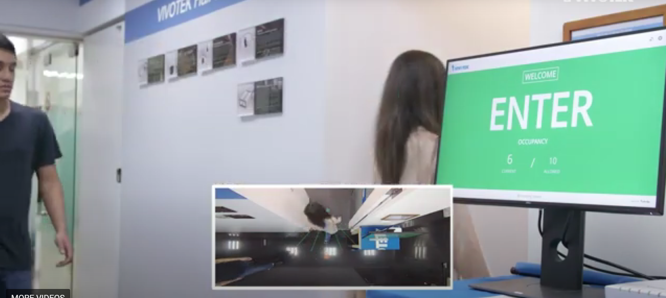translation, like ours, but with a phone camera.

This offers many of the same features as we have aimed to make, such as reading out the word, translating into hundreds of languages. Our equipment altogether costs only 12 pounds, rather than the hundreds of pounds for a phone.

The other project is the crowd management project which contains two parts, a people counter and a face mask detector. It can be used in areas where there are big groups of people actively working. This project will help the authorities. It uses a webcam to find who is wearing a face mask and how many people are in a certain area where the camera is focused. This saves many employees jobs of counting how many people are coming in. Our competitor is VIVOTEK’s Crowd Control Solution but this costs over $1000 and ours is a much less pricey model costing around 17 pounds excluding the raspberry pi.

Our future plans for this project are to make it compact and easily transportable and to improve it to give the user access to the word’s synonyms and antonyms. For the crowd management project, we will add more angles for the camera to view from and add a system that tracks the amount of time each person spent inside the building and also we could display the data on an LED Matrix. We will evaluate these future plans and this is a work in progress. We have tested both our projects with and without the electronics and with multiple pi’s.

**Conclusion:**

In conclusion, we have two main projects, the raspberry pi dictionary and the crowd management project. These both help the community in different ways, in ability-wise and in maintenance-wise.

Code: <https://github.com/vivek-kommi/PAConsulting>

YouTube Video Presentation: <https://www.youtube.com/watch?v=_xYUU16Vy78&t=86s>